GRANDSTREAM USER GUIDE

GRANDSTREAM MODEL GXP2170

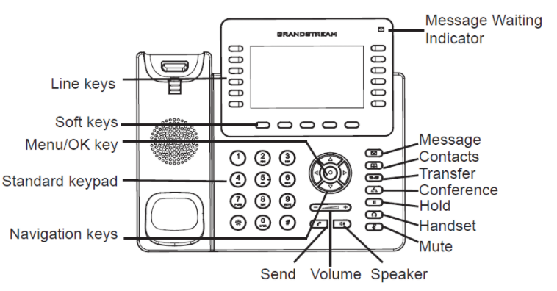
GRANDSTREAM MODEL GXP2170 - PHONE BUTTON AND FUNCTION CATALOG
Softkey
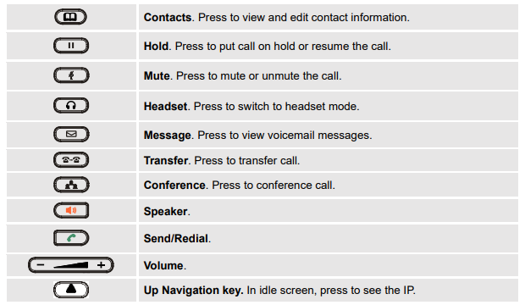

DIAL EXTERNAL
Dialing instructions are as follows:

- Local 1 + Area Code + Number
- Area Code + Number
- International calls - 011 + Country Code + Number + # key
- Emergency calls - 911 + # key for emergencies

Outbound call destination restrictions are on the various phone lines, depending on job function/level to help manage Township communications expense. Your level of access is initially set similar to what you required to perform your job on the old system, e.g., restricted to local calling area, nationwide, or international. You should route requests to change calling restrictions through your Department Head to the IT department.

INCOMING CALL

Pick up the handset, press the speaker key, or press answer

ENDING A CALL
- Place the handset back on the base or press the “End Call” soft key

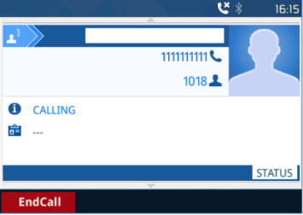

CALL HOLD/RESUME
- Hold: Place a call on ‘hold’ by pressing the hold button.
- Resume: Resume call by pressing the corresponding blinking LINE.

PICKING UP CALL
- To answer calls in a pickup group, just push the Pickup Group Call button

CALL FORWARDING
- Dial: *72: and enter the targeted call forwarding ext. ****#

CANCEL CALL FORWARDING
- Dial: *73
Directory/ LDAP Search

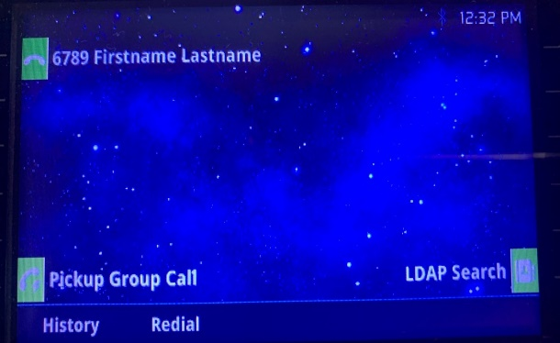
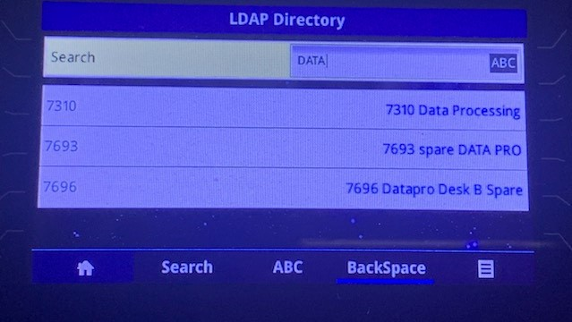

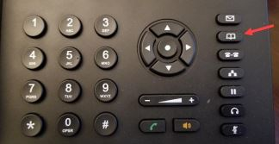

- To access the directory, press the LDAP Search button, for the listing of all extensions, scroll down using the down arrow button.
- Press the LDAP button, search by last name using number keys coinciding with the alphabet, spell last the name then press the search button.

TRANSFER CALLS

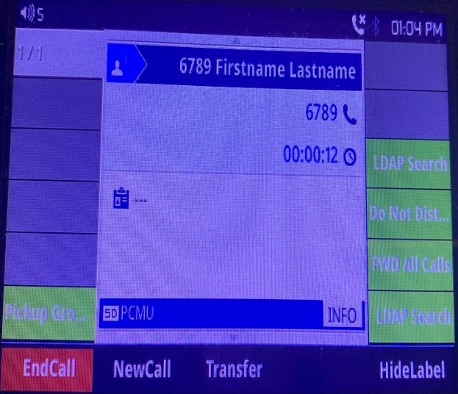
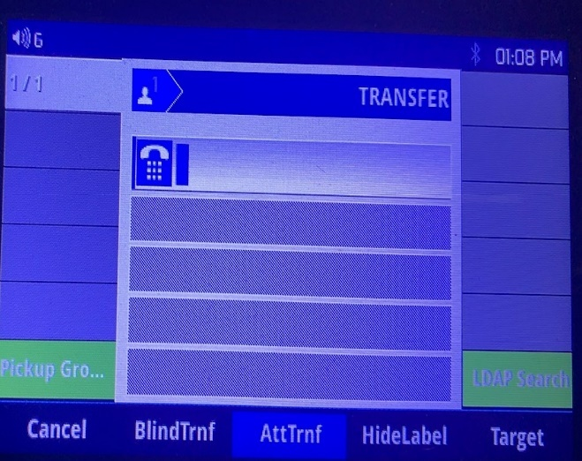

Transfer Blind or Attended:
A “blind” transfer sends the call to the desired party and immediately disconnects you from the call. You will not hear the called party ring or answer. (It’s as if the person dialed the desired party directly.)

An “attended” transfer keeps you on the line as the desired party’s line rings, and is either answered or goes to voice mail. You can then decide what to do after the party answers (and you announce the caller and then get off the call), or drop the transfer attempt (and maybe try transferring somewhere else).

How you accomplish a transfer depends greatly on whether your phone has been set up with one or more “transfer XXXX” buttons (shown with this icon: ), or with one or more “Busy Lamp Field” buttons (shown with this icon: and with green or red light: .). These buttons monitor whether another person’s phone is idle (green) or busy (red), etc.

TO DO A BLIND TRANSFER where the destination is one or your “transfer XXXX” buttons, then, while you are on the call, simply press one of those buttons and the call will instantly transfer. (You will be immediately disconnected from the caller.)

TO DO A BLIND TRANSFER where the destination is one of your “Busy Lamp Field” buttons (or any 4 digit extension of your choosing), you need to press the transfer button ( or ), press the desired Busy Lamp Field button (or enter the 4 digit extension), and then press the button to complete a Blind Transfer of the active call. (As soon as you hit the button, you are disconnected from the call.)

TO DO AN ATTENDED TRANSFER
- Start by pressing transfer button ( or ). This puts the initial call on HOLD! Then enter the 4 digts (or press an appropriate Busy Lamp Field button), and then press the (attended transfer) bottom soft buttons. This calls the new party, and you need to decide what you want to do depending on whether the new party picks up. If the new party picks up, announce the call, and then press the button to remove yourself from the call and connect the original party.
- If the new party doesn’t answer (or the call goes to voicemail), you can abandon the transfer by pressing and then to drop the transfer attempt and then  to take the original caller off of HOLD. (You can then try another transfer.) You should not just Transfer and “dump” the caller into the new voicemail system since they will not have heard the prompt (they were on hold!) and won’t realize that the system is waiting for them to record a message.

NOTE: if you intentionally want to call (or blind transfer someone) directly into someone’s voicemail, dial * followed by the 4 digit extension instead of just the 4 digit extension. This will bypass the phone ringing at all and route the call straight into voicemail. This is especially useful if the caller is asking for someone you know is not in the office at the moment. You can actually say “So and so is not in the office right now. Do you want to leave him/her a voicemail? If so, just blind transfer to *xxxx.

CONFERENCE CALLS
- While on an active call, press the conference button
- Dial the internal extension or external number to add to the conference.
- Press the Dial softkey (this puts the first party on the active call on HOLD.)
- Wait for the second party to answer, and then let them know that you would like to add them to a 3-way join or marge all three press confcall soft button to merge new call.

DO NOT DISTURB

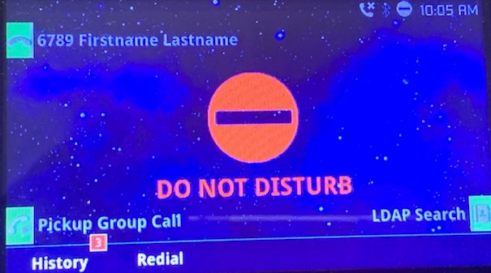

- This feature has been turned off because it has been deemed unreliable and difficult to turn off!

VOICEMAIL

VIRTUAL VOICEMAIL AND OR CHECKING VOICEMAIL FROM CELL PHONE

Dial-in main number (if outside) 732-329-4000 and then enter extension 7999# and follow prompted instructions to enter the extension number + # key , then the password and # key. (From your own phone, use the Envelope (Message) button, or dial *97# from the line you wish to check.).

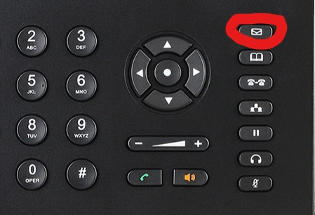

ACCESSING VOICEMAIL & SETTING GREETINGS
- Press the Message key (envelope)on your Grand stream phone or press * 97 from the phone to access voicemail
- Enter your password
- If still set to default password “1234”, you must change it (instructions below)
- Press 0 for Mailbox Options.
- To change password after mailbox options menu, select option “5”. Please avoid “trivial” passwords, e.g., 1111, 1234, 4565, 9876 and do not use leading 0’s, e.g., 0615 is not good.
- To record Name after mailbox options menu, select option “3”
- You have the option of recording up to four greeting: “unavailable”, “busy”, “no answer” and “temporary”. The “unavailable” message is only used if there is something wrong with your phone (so don’t use it!).
- At the very least, record a “no answer” message (option “6”). If you do not record any messages, the system will construct a message using your recorded name and an appropriate message, e.g., “John Doe” is busy. Also note, the “temporary” greeting will be used in all cases, so it might be best to use this to say something like “You’ve reached John Doe. I can’t answer your call right now so leave a detailed message.” (This would then be used when the line is busy, no answer, etc.)
- Record the message of your choice after the tone and press pound.
- To keep the message, press 1 to accept the message. If not satisfied, press 3 to re-record and repeat steps 5 and 6.

LISTENING TO NEW MESSAGES
- Press the Message key (Green Envelope).
- Enter your password, followed by the # key.
- Press 1 to listen to new messages.
- Follow the prompts to save, delete, etc.

FOR MULTI ACCOUNT PHONES:
- If an account on the phone has a voicemail, the Message Waiting Indicator will be blinking green.
- Pick your associated extension line
- To retrieve the voicemail, press the voicemail button. (Envelope Icon)
- Enter your password, followed by the # key.
- Press 1 to listen to new messages.
- Follow the prompts to save, delete, etc.

Index:

A “blind transfer” is one where you leave the call immediately. The user hears the ringing extension you just dialed (or that person’s voicemail if they are busy/don’t answer.”)

An “attended transfer” is one where you stay on the line until the desired party answers and you then can leave the call, cancel the transfer (and try someone else), etc.

LDAP Search
Note: the search will include first names as well, so a search like “ROB” will find ROBERTS, ANDREW; STROBEN, WILIAM, etc. It will also find WILLIAM, ROBERT. (You can also look up by partial extension number, e.g., search for 123 and you’ll get entries for 7123, 7223, 1234, etc.)

